Editors - Movie Clip Editor
Movie Clip Editor Introduction 2
Header 3
Clip Menu 3
Controls 3
Properties Region 4
Tracking Introduction 4
Views 5
Manual Lens Calibration 5
Camera and Object Motion Solving 5
Tools for Scene Orientation and Stabilization 5
Clip View Introduction 5
Tracking Marker 6
Point 6
Plain 6
Track 6
Clip Panel 7
Marker panel 7
Tracking Settings Panel 8
Extra Settings 9
Track panel 9
Tracks 9
Clear 9
Refine 10
Merge 10
Solve 10
Plane Track Panel 10
Solve Panel 10
Tripod 10
Keyframe 11
Refine 11
Solve Camera/Object Motion 11
Cleanup Panel 11
Geometry Panel 12
Orientation Panel 12
Scene Setup 12
Clip View Properties Introduction 12
Objects Panel 13
Track Panel 13
Track Preview Widget 14
Further Options 14
Plane Track Panel 15
Tracking Settings Panel 15
Marker Panel 15
Grease Pencil Panel 15
Camera Data 16
Camera 16
Lens 16
Marker 16
Marker Display 17
Marker Panel 17
Stabilization Introduction 17
How it works 18
Stabilization Tracks 18
Footage, Image and Canvas 19
The “dancing” black Borders 21
2D Stabilization Panel 21
Options 22
Workflow 23
The Simple Case 23
Avoid Problematic Footage 24
Elaborate Movements 25
Animating Stabilization Parameters 25
Irregular Track Setup 25
Graph View 26
Introduction 27
Header 27
Usage 28
Dope Sheet View 28
Header 29
Usage 29
Masking Introduction 29
S-Curves 30
Primitives 30
Selection & Editing 31
Selection 31
Editing 31
Control Points 31
Curve Handles 31
Feather 31
Animation 32
Show/Hide 32
Properties 32
Mask Layer 32
Example 33
Mask Display 33
Active Spline 33
Active Point 33
Parent 33
Mask Settings 34
Proxy/Timecode Panel 34
Proxy 34
Timecode 35
Options 35
Display Panel 35

Movie Clip Editor Introduction

The Movie Clip Editor has two main purposes, it can be used for for tracking or masking movies. The empty editor looks like the image below.
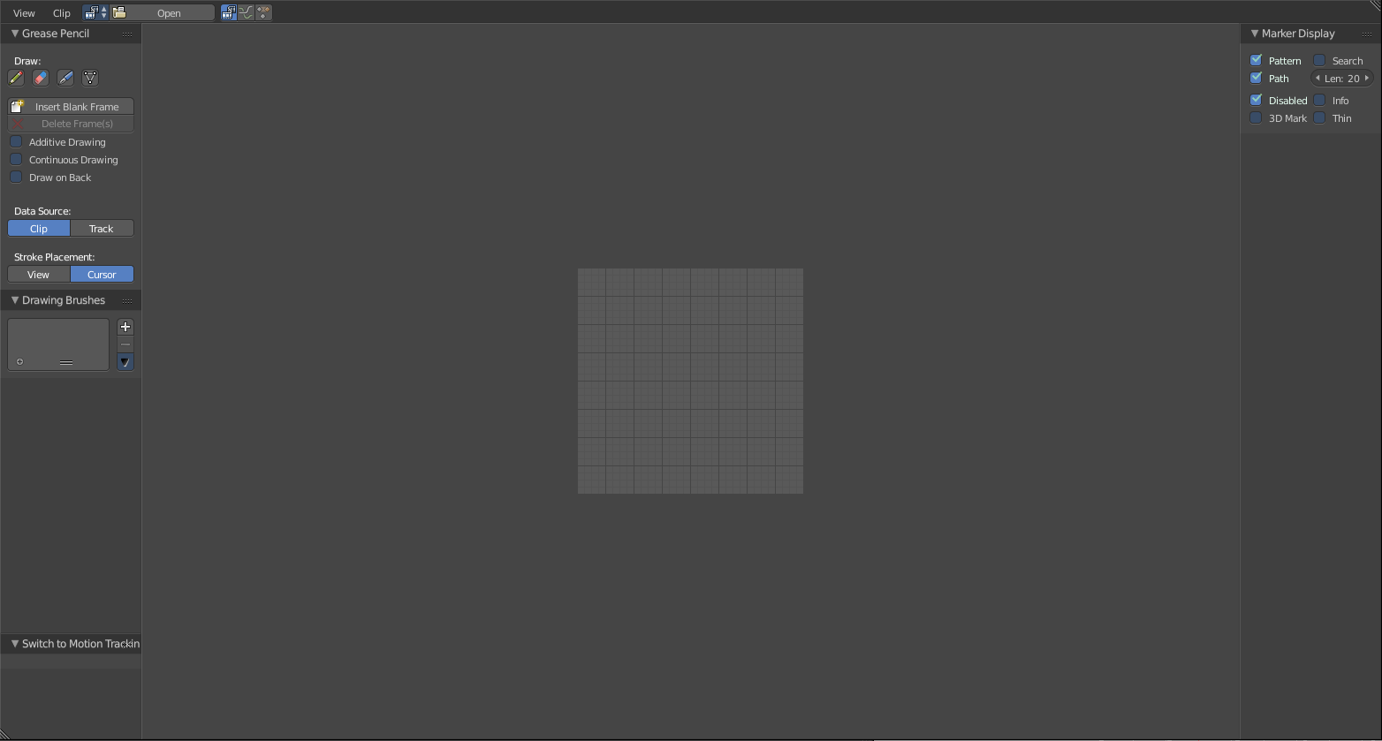
Movie Clip Editor interface.

Header

Clip Menu
- Open Clip

Controls
Movie Clip
Data-block menu used for add a movie file. Both movie files and image sequences can be used in the Clip editor. When a movie clip is loaded into the clip editor, extra panels are displayed in the interface.
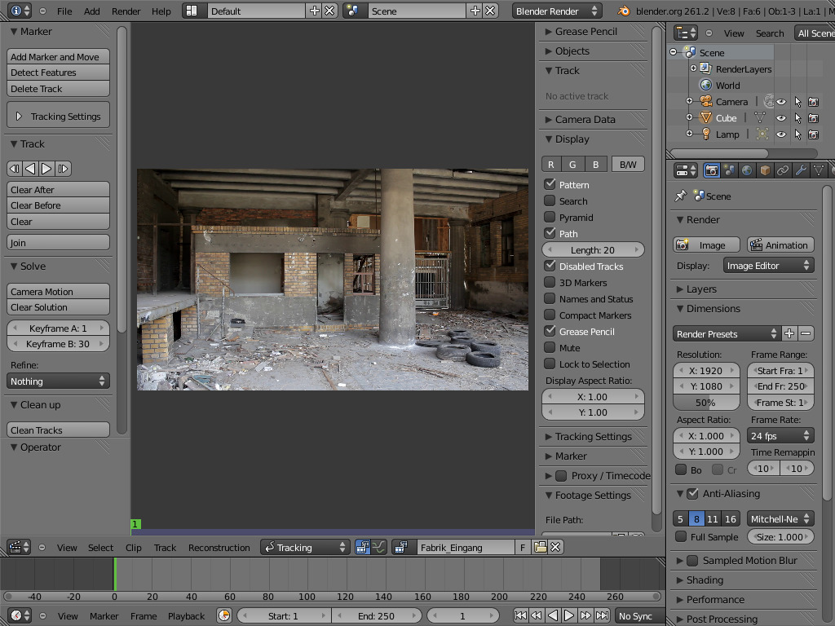
Movie Clip Editor with an Opened Clip.
Modes
- Motion Tracking
- Masking
Pivot Point
See Pivot Points.
Proportional Edit
See Proportional Edit.

Properties Region
Footage Settings
See Image Settings.

Tracking Introduction

Motion Tracking is used to track the motion of objects and applying that data to 3D object through the compositor. Blender’s motion tracker supports a couple of very powerful tools for 2D tracking and 3D motion tracking, including camera tracking and object tracking, as well as some special features like the plane track for compositing. Tracks can also be used to move and deform masks for rotoscoping in the Mask Editor, which is available as a special mode in the Movie Clip Editor.

Note
Bforartists has Load UI off by default. This means when you save a motion tracking file, and reopen it, then you will land in the default motion tracking layout again. With the dataset like the movie not selected. You have to manually set the movie as the active one for example.
With load UI enabled you will have all elements selected as you have saved it. So when you work with motion tracking, then it's a good idea to activate Load UI in the user preferences.

Views
In Tracking Mode there are three different views available. You can toggle between view modes using the View menu, which is located in the header. When you selected a view in the whole area of the Movie Clip editor will change. Hence, to display a curve or dope sheet view, the editor must be split into two, with one switched to the curve or dope sheet view.

Manual Lens Calibration
All cameras record distorted video. Nothing can be done about this because of the manner in which optical lenses work. For accurate camera motion, the exact value of the focal length and the “strength” of distortion are needed.
Currently, focal length can be automatically obtained only from the camera’s settings or from the EXIF information. There are some tools which can help to find approximate values to compensate for distortion. There are also fully manual tools where you can use a grid which is getting affected by distortion model and deformed cells defines straight lines in the footage.
You can also use the grease pencil for this – just draw a line which should be straight on the footage using poly line brush and adjust the distortion values to make the grease pencil match lines on the footage.
To calibrate your camera more accurately, use the grid calibration tool from OpenCV. OpenCV is using the same distortion model, so it should not be a problem.

Camera and Object Motion Solving
Blender not only supports the solving of camera motion, including tripod shots, but also the solving of object motion in relation to the motion of the camera. In addition to that there is the Plane Track, which solves the motion of all markers on one plane.
There are also plans to add more tools in the future, for example more automatic tracking and solving, multi-camera solving and constrained solutions.

Tools for Scene Orientation and Stabilization
After solve, you need to orient the real scene in the 3D scene for more convenient compositing. There are tools to define the floor, the scene origin, and the X/Y axes to perform scene orientation.
Sometimes, the video footage includes spurious jumps and tilting movements, like e.g. when using a hand held camera. Based on some tracked image elements, the 2D Stabilization is able to detect and compensate such movements to improve the quality of the final result.

Clip View Introduction

The Clip View is used is the main part of the of the Movie Clip editor. Almost all motion tracking tools are concentrated in the Movie Clip Editor.
It should be mentioned that the camera solver consists of three quite separate steps:
- 2D tracking of footage.
- Camera intrinsics (focal length, distortion coefficients) specification/estimation/calibration.
- Solving camera, scene orientation, and scene reconstruction.

Tracking Marker

Point

Marker schematic.
S scales the whole marker. The whole pattern area only will be scaled by pressing S twice; The Pattern can also be rotated using the R button which, depending on the used pivot point, will either rotate patterns around their own centers or rotate the whole markers around e.g. the median point.
To match the perspective transformation of a marker on a plane, the individual corners must be edited manually. Each marker corner can deform individually to define the shapes. Corner positions can be edited by dragging them with a mouse. Dragging with LMB will change the position of an individual corner.
Note
Note that deforming a pattern is not only useful for planar / affine tracking. Since only pixels within the pattern will be considered this can help to specify a better pattern to track even for simple position tracking.

The Search area can not be rotated; this is intentional. It doesn’t make sense to deform the search area.

Plain
The left bottom corner of the plane does have X/Y axis (X is red, Y is green) to help distinguishing orientation of the plane in space.
It is likely that corner of the plane object need to be manually adjusted. To do this sliding individual corners with mouse LMB or general transform tools G, R, S could be used.
Adjusting plane corners will keep it following the plane defined by tracks it was originally created from.

Track

Clip Panel
Prefetch
Fills cache with frames. As many frames as fits into cache are load form the drive. This allows to fill in the cache as fast as possible when you really need to track something, but this keeps CPU and drive bandwidth idle if you’ve got clip editor opened but not actually interacting with it.
Reload
ToDo.
Set Scene Frames
ToDo.

Marker panel
Add Marker and Move
Places a new marker at the position of the mouse (which is under the button in this case, not ideal but it is just how things work) and then it can be moved to the needed location. When it is moved to the desired position, LMB can be used to finish placing the new marker. Also, Return and Spacebar can be used to finish placing the marker. But it is faster to use Ctrl-LMB to place markers directly on the footage. This shortcut will place the marker in the place you have clicked. One more feature here: until you have released the mouse button, you can adjust the marker position by moving the mouse and using the track preview widget to control how accurately the marker is placed.
Detect Features
Detects all possible features on the current frame and places markers at these features. This operator does not take into account other frames, so it can place markers on features which belong to moving objects, and if camera is turning away from this shot, no markers would be placed on frames after the camera moved away.
There are several properties for this operator:
Placement
Used to control where to place markers. By default, they will be added through the whole frame, but you can also outline some areas with interesting features with grease pencil and place markers only inside the outlined area. That is how the “Inside Grease Pencil” placement variant works. You can also outline areas of no interest (like trees, humans and so) and place markers outside of these areas. That is how the “Outside Grease Pencil” placement variant works.
Margin
controls the distance from the image boundary for created markers. If markers are placed too close to the image boundary, they will fail to track really quickly and they should be deleted manually. To reduce the amount of manual clean-up, this parameter can be used.
Threshold
Limits minimal threshold for placing markers. This value comes from the feature detection algorithm and basically it means: low values means most probably this feature would fail to track very soon, high value means it is not much such track. Amount of markers to be added can be controlled with this value.
Distance
Defines the minimal distance between placed markers. It is needed to prevent markers from being placed too close to each other (such placement can confuse the camera solver).
Delete Track
is a quite self-explaining operator which deletes all selected tracks.

Tracking Settings Panel
This panel contains all settings for the 2D tracking algorithms.
Tracking Presets
ToDo.
Channels
ToDo.
Pattern Size, Search
ToDo.
Motion Model
Defines which possible motions tracking feature has. This option should be set depending on which motion a particular feature has and it’ll make tracking most accurate for such a motion.
Location only, Location+Rotation, Location+Scale, Location+Rotation+Scale, Affine
Perspective
Is usually used to track a planar feature, but often Affine is a good enough approximation and may have more stable tracks.
Pattern Match
Pattern Match controls which patterns get tracked; to be more precise, the pattern from which frame is getting tracked. Here is an example which should make things clearer.
The tracker algorithm receives two images inside the search area and the position of a point to be tracked in the first image. The tracker tries to find the position of that point from the first image in the second image.
Now, this is how tracking of the sequence happens. The second image is always from a frame at which the position of marker is not known (next tracking frame). But a different first image (instead of the one that immediately precedes the second image in the footage) can be sent to the tracker.
Keyframe
An image created from a frame on which the track was keyframed. This configuration prevents sliding from the original position (because the position which best corresponds to the original pattern is returned by the tracker), but it can lead to small jumps and can lead to failures when the feature point is deformed due to camera motion (perspective transformation, for example).
Previous Frame
Keyframes for tracks are creating every frames, and tracking between keyframed image and next image is used. In this configuration the pattern is tracking between two neighboring frames. It allows dealing with cases of large transformations of the feature point but can lead to sliding from the original position, so it should be controlled.
Prepass
Enables a two pass tracking, where the first pass is a brute force tracking of location only, and the second pass will use tracking of the full motion model refining the first pass.
Normalize
Means patterns will be normalized by their average intensity while tracking, to make them invariant to illumination changes. An example where this is useful is a scene where a marker moves in the shadow of an object.
Copy From Active Track
Tracker settings only – ToDo.

Extra Settings
Use Mask
ToDo.
Correlation
Is now a single value for all tracking settings and defines the minimal correlation between a matched pattern and a reference to be considered a successful tracking. If the tracker is giving up too easily, decrease this value, or if the tracker is slipping too much when it should give up sooner, increase this value.
Frames Limit
Controls how many frames can be tracked when the Track Sequence operator is called. So, each Track Sequence operation would track maximum Frames Limit frames. This also helps to notice slide-off of tracks and correct them.
Margin
Can be used disable tracks when they become too close to the image boundary. This slider sets “too close” in pixels.
Speed
Marker settings only – Can be used to control the speed of sequence tracking. This option does not affect the quality of tracking; it just helps to control if tracking happens accurately. In most cases tracking happens much faster than real time, and it is difficult to notice when a track began to slide out of position. In such cases Speed can be set to Double or Half to add some delay between tracking two frames, so slide-off would be noticed earlier and the tracking process can be canceled to adjust positions of tracks.
Weight
See Track Weight.

Track panel

Tracks
The first row of buttons is used to perform tracking of selected tracks (i.e. following the selected feature from frame to frame). Tracking can happen (in order of buttons):
- Backward one frame
- Backward along the sequence
- Forward along the whole sequence
- Forward one frame
This operator depends on settings from the Tracking Settings panel, which will be described later. If during sequence tracking the algorithm fails to track some markers, they will be disabled and tracking will continue for the rest of the markers. If the algorithm fails when tracking frame-by-frame, the marker is not disabled, and the most likely position of the feature on the next frame is used.

Clear
Action
Clear (After/Remained) (left arrow icon)
Deletes all tracked and keyframed markers before the current frame for all selected tracks.
Clear (Before/Up-to) (right arrow icon)
Deletes all tracked and keyframed markers after the current frame for all selected tracks.
Clear (Track Path/All)
Clears all markers except the current one from all selected tracks.
Clear Active
ToDo.

Refine
This operator will run a tracker from previous keyframe to current frame for all selected markers. Current markers positions are considering initial position guess which could be updated by a tracker for better match.
Useful in cases when feature disappears from the frame and then appears again. Usage in this case is the following:
- When feature point re-appeared on frame, manually place marker on it.
- Use Refine Markers operation (which is in Track panel) to allow tracker to find a better match.
Depending on direction of tracking use either Forwards or Backwards refining. It’s easy: if tracking happens forwards, use Refine Forwards, otherwise use Refine Backwards.

Merge
Join Tracks
This operator joins all selected tracks into one. Selected tracks should not have common tracked or keyframed markers at the same frame.

Solve

Plane Track Panel
The Create Plane Track operator creates a new plane track. This can be used to replace things like billboards and screens on the footage with another image or video. It also might be used for masking.
This button will create a plane object which is deforming in the same way as plane defined by all selected point tracks. At least four feature points tracked across the footage which belongs to the plane one wants to replace are needed. More tracks will give better estimation of plane motion.
Feature points used to estimate plane motion could be used from any place on the plane, meaning it’s not necessarily need to be corners. Corners are not always easy to be tracked, they might be occluded. In this case you can position tracked features that lay on the same plane far away from the actual plane which should be replaced.
It is also possible to have some tracks appear and disappear during the time, it’s only required that two neighbor frames have at least 4 common tracks.

Solve Panel

Tripod
Tripod Motion can be used for footage where the camera does not move and only rotates. Such footage can’t be tracked with a generic solver approach, and it is impossible to determine the actual feature points in space due to a lack of information. So this solver will solve only the relative camera rotation and then reproject the feature points into a sphere, with the same distance between feature and camera for all feature points.
Note
Please note, that this is special type of camera solver and it behaves different from regular solver. It means using more tracks doesn’t imply more accurate solution. Having 5-10 tracks on frame is likely what shall be commonly used for this kind of solver.

Keyframe
Keyframe
Automatically select keyframes for initial reconstruction. This option enables complex algorithms which tries to find a keyframe pair with minimal reconstruction error and best scene scale guess.
Keyframe A, B Q, E
Start (A) and End (B) frame of the range used for reconstruction.

Refine
The Refine option specifies which parameters should be refined during solve. Such refining is useful when you are not sure about some camera intrinsics, and solver should try to find the best parameter for those intrinsics. But you still have to know approximate initial values – it will fail to find correct values if they were set completely incorrectly initially.

Solve Camera/Object Motion
The Camera Motion operator solves the motion of camera using all tracks placed on the footage and two keyframes specified on this panel. There are some requirements:
- There should be at least eight common tracks on the both of the selected keyframes.
- There should be noticeable parallax effects between these two keyframes.
If everything goes smoothly during the solve, the average reprojection error is reported to the information space and to the clip editor header. Reprojeciton error means the average distance between reconstructed 3D position of tracks projected back to footage and original position of tracks. Basically, reprojection error below 0.3 means accurate reprojection, (0.3 - 3.0) means quite nice solving which still can be used. Values above 3 means some tracks should be tracked more accurately, or that values for focal length or distortion coefficients were set incorrectly.

Cleanup Panel
This panel contains a single operator and its settings. This operator cleans up bad tracks: tracks which are not tracked long enough or which failed to reconstruct accurately.
Frames
ToDo.
Error
Error threshold value.
Action
Several actions can be performed for bad tracks:
Selected
They can simply be selected.
Delete Track
The whole track can be deleted.
Delete Segments
Bad segments of tracked sequence can be removed.

Geometry Panel
3D Markers to Mesh
Converts the reconstructed points into a point cloud (single mesh). ToDo.
Link Empty to Track
ToDo.

Orientation Panel
Scene orientation tools can be used for orienting object to bundles.
Floor
Select three markers that should lay on the floor plane. ToDo.
Wall
Define world orientation based on points on the wall.
Set Origin
ToDo.
Set X, Y Axis
ToDo.
Set Scale
Object has got scale to define “depth” in camera space.
Apply
Apply scale on scene solution.
Distance
ToDo.

Scene Setup
Set as Background
Sets the clip currently being edited as the camera background for all visible 3D Views. If there is no visible 3D Views or the Clip Editor is open in full screen, nothing will happen.
Setup Tracking Scene
ToDo.

Clip View Properties Introduction

Objects Panel
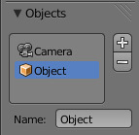
Objects Panel.
This panel contains a list view with all objects which can be used for tracking, camera or object solving. By default there is only one object in this list which is used for camera solving. It cannot be deleted and other objects cannot be used for camera solving; all added objects are used for object tracking and solving only. These objects can be referenced from Follow Track and Object Solver constraints. Follow Track uses the camera object by default.
If some tracks were added and tracked to the wrong object, they can be copied to another object using Track ‣ Copy Tracks and Track ‣ Paste Tracks.
The usage for all kind of objects (used for camera and object tracking) is the same: track features, set camera data, solve motion. Camera data is sharing between all objects and refining of camera intrinsics happens when solving camera motion only.

Track Panel
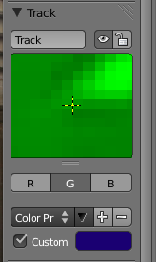
Track Panel.
Name
The track name can be changed with this field. Track names are used for linking tracking data to other areas, like a Follow Track constraint.
Enable (eye icon)
This toggle controlled the marker’s enabled flag. If a marker is disabled, its position is not used either by solver nor by constraints.
Lock (padlock icon)
The toggle controls whether the track is locked. Locked tracks cannot be edited at all. This helps to prevent accidental changes to tracks which are “finished” (tracked accurate along the whole footage).

Track Preview Widget
The widget in this panel is called “Track Preview” and it displays the content of the pattern area. This helps to check how accurately the feature is being tracked (controlling that there is no sliding off original position) and also helps to move the track back to the correct position. The track can be moved directly using this widget by mouse dragging.
If an anchor is used (the position in the image which is tracking is different from the position which is used for parenting), a preview widget will display the area around the anchor position. This configuration helps in masking some things when there is no good feature at position where the mask corner should be placed. Details of this technique will be written later.
There is small area below the preview widget which can be used to enlarge the vertical size of preview widget (the area is highlighted with two horizontal lines).

Further Options
Channels
Tracking happens in gray-scale space, so a high contrast between the feature and its background yields more accurate tracking. In such cases disabling some color channels can help.
Grayscale Preview (B/W)
Display the preview image as grayscale even if all channels are enabled.
Alpha Preview (B/W icon)
ToDo.
Weight
When several tracks are used for 3D camera reconstruction, it is possible to assign a reduced weight to some tracks to control their influence on the solution result. This parameter can (and often need to be) animated.
Altering the weights of problem tracking markers can correct or greatly reduce undesirable jumps. Another use of Track Weights is when you want to reconstruct a scene from your camera solution. In that case you can first carefully track and solve your scene, and once you’re done, lock all your markers with Ctrl-L, set the tracker weight in the Extra Settings of the tracker settings to zero and use the feature detection to quickly add lots of markers. Now track them and solve the scene again. Since their weight is zero they will not influence your solution at all, but you will have lots of good reference points in your scene.
Stabilization Weight
While Weight parameter is used for 3D reconstruction, the Stabilization Weight is used to control 2D stabilization.
Color Presets
The preset for the Custom Color.
Custom Color
This setting overrides the default marker color used in the clip editor and 3D View, and it helps to distinguish different type of features (for example, features in the background vs. foreground and so on). Color also can be used for “grouping” tracks so a whole group of tracks can be selected by color using the Select Grouped operator.
Tip
To select good points for tracking, use points in the middle of the footage timeline and track backwards and forwards from there. This will provide a greater chance of the marker and point staying in the camera shot.

Plane Track Panel
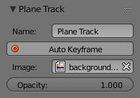
Plane Track Panel.
Its properties are shown only when a plane track is selected. Firstly, the name of the selected plane track is shown. It can also be changed from here.
Auto Keyframe
Toggles the auto-keyframing for corners of the plane track. With this enabled, keyframes will automatically get inserted when any corner is moved.
Image
Field to select an image which will be displayed inside the plane track. This image is for preview purposes in movie clip editor only. To include it in your final render, see Plane Track Deform node.
Opacity
Used to set the opacity of this image. Again, this is for display purposes only, and will not affect your final render.

Tracking Settings Panel
This panel contains tracker settings for each marker.

Marker Panel
Marker schematic.
This panel contains numerical settings for marker position, pattern and search area dimensions, and offset of anchor point from pattern center. All sliders are self-explanatory.

Grease Pencil Panel
Grease pencil strokes can be enabled/disabled with the checkbox in the panel header. It is a standard grease pencil panel where new grease pencil layers and frames can be controlled. There is one difference in the behavior of the grease pencil from other areas – when a new layer is created “on-demand” (when making a stroke without adding a layer before this) the default color for the layer is set to pink. This makes the stroke easy to notice on all kinds of movies.

Camera Data

This panel contains all settings of the camera used for filming the movie which is currently being edited in the clip editor.

Camera
Camera Presets
Predefined settings can be used here. But such settings as distortion coefficients and principal point are not included in the presets and should be filled in even if camera presets are used.
Sensor
Width
Is the width of the CCD sensor in the camera. This value can be found in camera specifications.
Pixel Aspect Ratio
Is the pixel aspect of the CCD sensor. This value can be found in camera specifications, but can also be guessed. For example, you know that the footage should be 1920×1080, but the images themselves are 1280×1080. In this case, the pixel aspect is: 1920 / 1280 = 1.5.
Optical Center
Is the optical center of the lens used in the camera. In most cases it is equal to the image center, but it can be different in some special cases. Check camera/lens specifications in such cases. To set the optical center to the center of image, there is a Return button below the sliders.

Lens
Focal Length
Is self-explanatory; it is the focal length with which the movie was shot. It can be set in millimeters or pixels. In most cases focal length is given in millimeters, but sometimes (for example in some tutorials on the Internet) it is given in pixels. In such cases it is possible to set it directly in the known unit.
Lens Distortion
Are coefficients used to compensate for lens distortion when the movie was shot. Currently these values can be tweaked by hand only (there are no calibration tools yet) using tools available in Distortion mode. Basically, just tweak K1 until solving is most accurate for the known focal length (but also take grid and grease pencil into account to prevent “impossible” distortion).
K1, K2 and K3

Marker

Marker Display
Pattern
Can be used to disable displaying of rectangles which correspond to pattern areas of tracks. In some cases it helps to make the clip view cleaner to check how good tracking is.
Search Alt-S
Can be used to disable displaying of rectangles which correspond to search areas of tracks. In some cases it helps to make the clip view cleaner to check how good tracking is. Only search areas for selected tracks will be displayed.
Path
And Length control displaying of the paths of tracks. The ways tracks are moving can be visible looking at only one frame. It helps to determine if a track jumps from its position or not.
Disabled Alt-D
Makes it possible to hide all tracks which are disabled on the current frame. This helps to make view more clear, to see if tracking is happening accurately enough.
Info
Displays information such as track name and status of the track (if it is keyframed, disabled, tracked or estimated). Names and status for selected tracks are displayed.
3D Markers
Makes sense after solving the movie clip, and it works in the following way: the solved position of each track gets projected back to the movie clip and displayed as a small point. The color of the point depends on the distance between the projected coordinate and the original coordinate: if they are close enough, the point is green, otherwise it will be red. This helps to find tracks which were not solved nicely and need to be tweaked.
Thin
The way in which markers are displayed compact (black outline and yellow foreground color) makes tracks visible on all kind of footage (both dark and light). But sometimes it can be annoying and this option will make the marker display more compactly – the outline is replaced by dashed black lines drawn on top of the foreground, so that marker areas are only 1px thick.

Marker Panel

Marker schematic.
This panel contains numerical settings for marker position, pattern and search area dimensions, and offset of anchor point from pattern center. All sliders are self-explanatory.

Stabilization Introduction

The 2D video stabilization is a feature built on top of Blender’s image feature tracking abilities: we use some tracking points to remove shakiness, bumps and jerks from video footage. Typically, image stabilization is part of a 2D workflow to prepare and improve footage prior to further processing or modeling steps. This page helps to understand how it works, introduces related terms and concepts, describes the available interface controls in detail and finally gives some hints about usage in practice.
Typical usage scenarios of the stabilizer:
- fix minor deficiencies (shaky tripod, jerk in camera movement)
- “poor man’s steadycam” (when a real steadycam was not available, affordable or applicable)
- as preparation for masking, matching and rotoscoping
It is not uncommon for 2D stabilization to have to deal with somewhat imperfect and flawed footage.

How it works
To detect spurious movement in a given shot, we’ll assume a simplified model about this movement. We then try to fit the movement of tracked features with this simplified model to derive a compensation. Of course, this works only to the degree our model is adequate – yet in practice, this simplified approach works surprisingly well even with rather complicated shots, where our basic assumption was just an approximation of much more elaborate movements.
This simplified model underlying the 2D stabilization as implemented here assumes movement by an affine-linear transform:
- the camera is pushed up/down/sideways by some translation component
- the image is then tilted and scaled around a pivot point (rotation center)
To compensate movement according to this simplified model, the 2D stabilizer proceeds in two steps. First we try to detect the translation offset from the weighted average of all translation tracking points. After compensating this translation component, we then use additional rotation/scale tracking points to detect rotation around a given pivot point. Again, we detect rotation and scale changes through a weighted average of all the rotation/scale tracking points given.
In the current version, the pivot point is anchored to the weight center of the translation tracking points. So effectively the detected translation is already factored out. In some cases this is not optimal, especially when tracks have gaps or do not cover the whole duration of the footage – we plan further options to better control the pivot point in future releases.

Stabilization Tracks
Thus, as foundation for any image stabilization, we need tracked image features to derive the movements. These tracking points or “tracks” can be established with Blender’s image feature tracking component The right choice of points to track is somewhat tricky, yet crucial for successful image stabilization. Often, we’re here because we’ll have to deal with imperfect footage. In such cases, the averaging of tracks helps to work around image or tracking errors at some point. Moreover, when the footage contains perspective induced movements, symmetrically placed tracking points above and below the horizon can be used to cancel out spurious movement and get stabilization to the focal area in between.
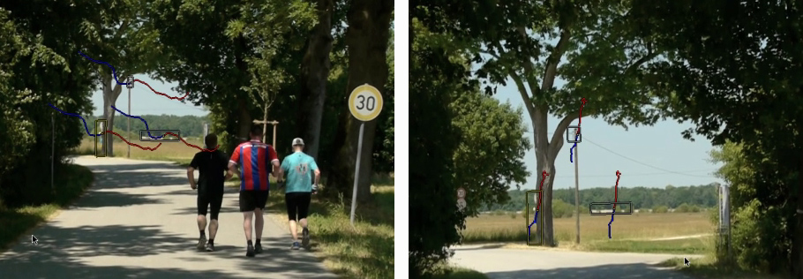
Diverging movements caused by perspective.
Tracks can be added in two groups
- first of all is the list of tracks to be used to compensate for jumps in the camera location. From all the tracking points added to this group, we calculate a weighted average. We then try to keep this average location constant during the whole shot. Thus it is a good idea to use tracking markers close to and centered around the most important subject.
- a second selection of tracks is used to keep the rotation and scale of the image constant. You may use the same tracks for both selections. But usually it is best to use tracking points with large distance from the image center, and symmetrically, on both sides, to capture the angular movements more precisely. Similar to the “location” case, we calculate an average angular contribution and then try to keep this value constant during the whole shot.

Footage, Image and Canvas
When talking about the movement stabilization of video, we have to distinguish several frames of reference. The image elements featured by the footage move around irregularly within the footage’s original image boundaries – this is the very reason why we are using the stabilizer. When our attempt at stabilization was successful, the image elements can be considered stable now, while in exchange the footage’s image boundaries have taken on irregular movement and jump around in the opposite way. This is the immediate consequence of the stabilizer’s activity.
Since the actual image elements, i.e the subject of our footage can be considered stable now, we may use these as a new frame of reference: we consider them attached to a fixed backdrop, which we call the canvas. Introducing this concept of a “canvas” helps to deal with deliberate movements of the camera. And beyond that, it yields an additional benefit: It is very frequent for the pixels of video footage to be non square. So we have to stretch and expand those pixels, before we’re able to preform any sensible rotation stabilization. Thus the canvas becomes, by definition, the reference for an undistorted display of the image contents.
But when the camera was moved intentionally, we have to consider yet another frame of reference beyond the canvas: namely the frame (or “cadre”) of the final image we want to create. To understand this distinction, let’s consider a hand-held, panning shot to the right: Since our camera was turned towards the right side, the actual image contents move towards the left side within the original image frame. But let’s assume the stabilizer was successful with “fixing” any image contents relative to the canvas – which in turn means, that the original image boundaries start to move irregularly towards the right side, and the contents of the image will begin to disappear gradually behind the left boundary of the original image. After some amount of panning, we’ll have lost all of our original contents and just see an empty black image backdrop. The only solution to deal with that problem is to move the final image frame along to the right, thus following the originally intended panning movement. Of course, this time, we do want to perform this newly added panning movement in a smooth and clean way.
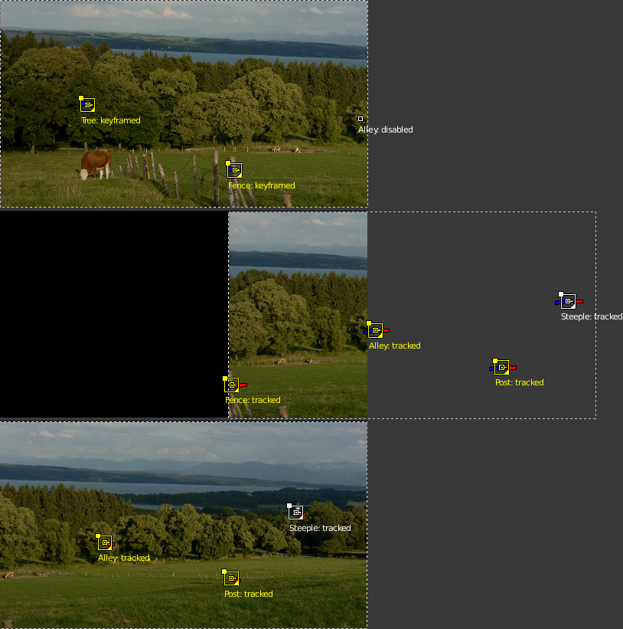
Stabilizing a panning shot.
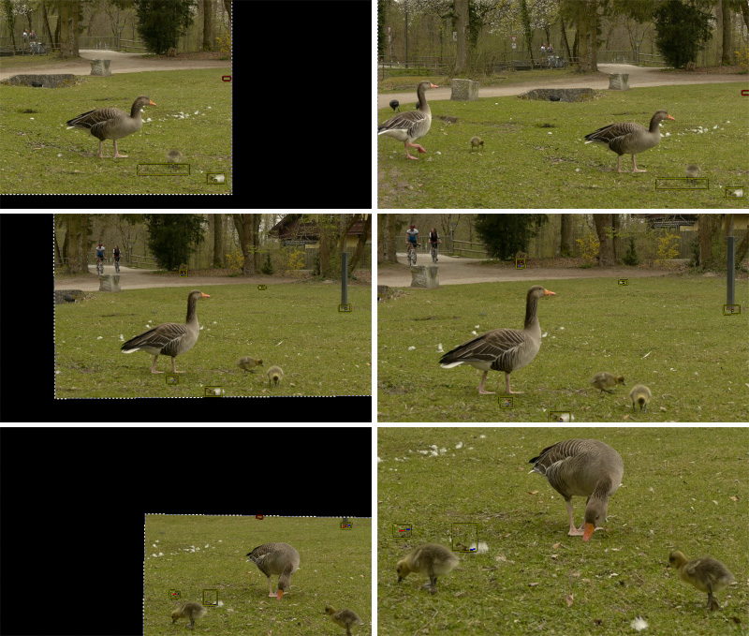
Restoring the expected camera movement.
To allow for such a compensation and to reintroduce deliberate panning, or tilting and zoom of the resulting image, the stabilizer offers a dedicated set of controls: Expected position, Expected rotation and Expected scale. These act like the controls of a virtual camera filming the contents we have fixed onto the canvas. By animating those parameters, we’re able to perform all kinds of deliberate camera movements in a smooth fashion.

The “dancing” black Borders
As explained above, when we succeed with stabilizing the image contents, the boundaries of the original footage start to jump around in the opposite direction of the movements compensated. This is inevitable – yet very annoying, since due to the irregular nature of these movements, these “dancing black borders” tend to draw away attention from the actual subject and introduce an annoying restlessness. Thus our goal must be to hide those dancing borders as good as possible. A simple solution is to add a small amount of zoom. Sometimes we’ll also need to animate the parameter Expected position in order to keep the image centered as good as we can – this helps to reduce the amount of zoom necessary to remove those annoying borders.
The Autoscale function can be used to find the minimal amount of zoom just sufficient to remove those black borders completely. However, if the camera jumps a lot, the autoscale function often zooms in too much, especially since this calculation aims at finding a single, static zoom factor for the whole duration of the footage. When this happens, you’ll typically get overall better results with animating both the zoom factor and the expected position manually.

2D Stabilization Panel

There is one extra panel which is available in reconstruction mode – 2D Stabilization Panel. The purpose of this feature is to smooth out jerky camera handling on existing real world footage. To activate the 2D stabilizer, you need to set the toggle in the panel, and additionally you need to enable Display Stabilization in the Display panel. Then you’ll need to set up some tracking points to detect the image movements.
The 2D Stabilization panel is used to define the data used for 2D stabilization of the shot. Several options are available in this panel: you may add a list of tracks to determine lateral image shifts and another list of tracks to determine tilting and zooming movements. Based on the average contribution of these tracks, a compensating movement is calculated and applied to each frame.
When the footage includes panning and traveling movements, the stabilizer tends to push the image out of the visible area. This can be compensated by animating the parameters for the intentional, “expected” camera movement.

Options
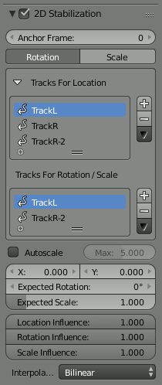
2D Stabilization Panel.
Note
To activate the 2D stabilizer, you need to set the toggle in the panel, and additionally you need to enable Display Stabilization in the Display panel.

Anchor Frame
Reference point to anchor stabilization: other frames will be adjusted relative to this frame’s position, orientation and scale. You might want to select a frame number where your main subject is featured in an optimal way.
Stabilization Type
Rotation
In addition to location, stabilizes detected rotation around the rotation pivot point, which is the weighted average of all location tracking points.
Scale
Compensates any scale changes relative to center of rotation.
Tracks For Stabilization
Location
List of tracks to be used to compensate for camera jumps, or location movement.
Rotation/Scale
List of tracks to be used to compensate for camera tilts and scale changes.
Autoscale
Finds smallest scale factor which, when applied to the footage, would eliminate all empty black borders near the image boundaries.
Max
Limits the amount of automatic scaling.
Expected Position X/Y
Known relative offset of original shot, will be subtracted, e.g. for panning shots
Expected Rotation
Rotation present on original shot, will be compensated, e.g. for deliberate tilting.
Expected Zoom
Explicitly scale resulting frame to compensate zoom of original shot.
Influence
The amount of transformation applied to the footage can be controlled. In some cases it is not necessary to fully compensate camera jumps. The amount of stabilization applied to the footage can be controlled. In some cases you may not want to fully compensate some of the camera’s jumps. Please note that these “* Influence” parameters do control only the compensation movements calculated by the stabilizer, not the deliberate movements added through the “Expected *”-parameters.
Interpolate
The stabilizer calculates compensation movements with sub pixel accuracy. Consequently, a resulting image pixel needs to be derived from several adjacent source footage pixels. Unfortunately, any interpolation causes some minor degree of softening and loss of image quality.
Nearest
No interpolation, uses nearest neighboring pixel. No interpolation, use nearest neighboring pixel. This setting basically retains the original image’s sharpness. The downside is we also retain residual movement below the size of one pixel, and compensation movements are done in 1 pixel steps, which might be noticeable as irregular jumps.
Bilinear
Simple linear interpolation between adjacent pixels.
Bicubic
Highest quality interpolation, most expensive to calculate

Workflow

Depending on the original footage’s properties, achieving good stabilization results might be simple and easy, or it might require some work, dedication and careful planning. This section covers some practical considerations to help improving the results.

The Simple Case
Whenever the camera is basically fixed, or at least “almost” stationary, and the footage is crisp and without motion blur, perfect stabilization is easy to achieve. This might be the case when a tripod was used, but wind or vibrations on the floor (e.g. on a stage) caused some minor shakes. Shoulder camera shots done by an experienced operator also frequently fall into this category.
- Use as few points as possible. Start with a single point right on the main subject.
- Track this single point as accurate as possible. Beware of movements and shape changes of the tracked feature. Proceed in small increments (e.g. 50 frames), zoom in and readjust the target point manually when it drifts away. Another option is to use a larger target area for tracking; since we’re tracking only a single point, the slower tracking speed might be acceptable.
- After enabling the basic (location) stabilization, consider if you really need rotation stabilization. Often, some minor, slow swinging movements are not really noticeable and do not warrant the additional working time and quality loss caused by rotation and scale stabilization.
- For rotation, start with one extra point, well spaced but preferably still attached to the main subject.
- Consider to fix some slow residual motion by manually animating the “Expected *” parameters, before you even think of adding more tracking markers. Because doing so is often not worth the effort.
- If you need to add more points, the most important goal is to achieve symmetry. Place location tracking points symmetrically above and below the horizon. Place rotation tracking points into diagonally opposed direction, always centered around the main focal area.

Avoid Problematic Footage
The 2D stabilizer can not work miracles; some flaws simply can not be fixed satisfactory. Notorious issues are motion blur, rolling shutter, pumping autofocus and moving compression artifacts. Especially if you do succeed with basic stabilization, such image flaws become yet the more noticeable and annoying. When on set or on location, it might be tempting to “fix matters in postpro”. Resist that deception, it rarely works out well.
- Prefer a short exposure time to avoid motion blur. While motion blur is good to render filmed movements more smooth and natural, it seriously impedes the ability to track features precisely. As a guideline, try to get at least to 1/250 s
- Prefer higher frame rates. The more temporal resolution the stabilizer has to work on, the better the results. If you have the option to choose between progressive and interlaced modes, by all means use interlaced and deinterlace the footage to the doubled frame rate. This can be done with the yadif filter of FFmpeg: use the mode 1 (send_field).
- Beware of Rolling Shutter. Avoid fast lateral movements. If you can, prefer a camera which produces less rolling shutter. Also, using a higher frame rate reduces the amount of rolling shutter; another reason to prefer interlaced over progressive for the purpose at hand.
- Switch off autofocus. Better plan your movement beforehand, set a fixed focus and rely on depth-of-field through using a small aperture. Pumping movements might not be so noticeable to the human observer, but the feature tracking tends to slide away on defocused image elements; fixing this manually after the fact can cause a huge waste of time.
- Increase the lighting level, at least use a higher sensitivity. This helps to set a fast shutter speed plus a small aperture. Better lighting and good exposure also help to reduce the impact of compression artifacts. If you can, also select a codec with less data reduction, better color space etc. Inevitably, we’re loosing some quality through the interpolation necessary for stabilization. Plus we’re loosing some quality due to color space conversion.

Elaborate Movements
When the footage builds on elaborate intended movement of the camera, the process of stabilization becomes more involved – especially when there is a shift in the main area of interest within the shot. When working with many tracks and fine grained animation, it is easy to get into a situation where additional manipulations actually decrease the quality, while it might be hard to spot and locate the root cause of problems. Recommendation is to proceed systematically, starting from the general outline down to tweaking of specific aspects.
- Understand the nature of the movements in the shot, both the intended and the accidental.
- Track some relevant features for location.
- Establish the basic location stabilization. This includes the decision, which feature to use for what segment of the shot. Work with the track weights to get an overall consistent movement of the weight center, in accordance with the inherent focus of the shot.
- Define the panning movements of the virtual camera (through animation of the Expected Position parameter)
- Add tracking for rotation and zoom stabilization
- Fine tuning pass:
Break down the whole duration of the shot into logical segments to define the intended camera movement. Then refine those segments incrementally step by step, until the overall result looks satisfactory...

Animating Stabilization Parameters
Animating some parameters over duration of the shot is often necessary, at least to get the final touch, including control of the scale factor to hide the dancing black borders. Unfortunately there is a known limitation in the current version: it is not possible to open the generic animation editors (F-curve and dope sheet) for animation data beyond the 3D scene. So, while it is possible to set key frames right within the UI controls of the stabilizer (either through pressing the I key or with the help of the context menu), it is not possible to manipulate the resulting curves graphically. The only way to readjust or remove a misguided keyframe is to locate the timeline to the very frame and then use the context menu of the animated UI control. (Hint: the color of the UI control changes when you have located at precisely the frame number of the keyframe)

Irregular Track Setup
It might not be possible to track a given feature over the whole duration of the shot. The feature might be blurred or obscured; it might even move out of sight entirely, due to deliberate camera movement. In such a situation, we need another tracked feature to take on it’s role, and we need some overlap time to get a smooth transition without visible jump.
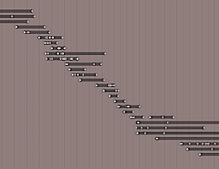
Irregular Tracks.
The stabilizer is able to deal with gaps and partial coverage within the given tracks. However, the basic assumption is that each track covers a single, fixed reference point whenever there is any usable/enabled data. Thus, you must not “re-use” a given track to follow several different points, rather you should disable and thus end one track, when tracking this feature is no longer feasible. You may include “gaps”, when a tracking point is temporarily disabled or unavailable, but you should start a new track for each distinct new feature to be tracked.
Each track contributes to the overall result by the degree controlled through its Stab Weight parameter. It is evaluated on a per frame base, which enables us to control the influence of a track by animating this Stab Weight. You may imagine the overall working of the stabilizer as if each tracking point “drags” the image through a flexible spring: When you turn down the Stab Weight of a tracking point, you decrease the amount of “drag” it creates. Sometimes the contribution of different tracks has to work partially counter each other. This effect might be used to cancel out spurious movement, e.g. as caused by perspective. But when, in such a situation, one of the involved tracks suddenly goes away, a jump in image position or rotation might be the result. Thus, whenever we notice a jump at the very frame where some partially covered track starts or ends, we need to soften the transition. We do so by animating the Stab Weight gradually down, so that it reaches zero at the boundary point. In a similar vein, when we plan a “handover” between several partially covered tracks, we define a cross-fade over the duration where the tracks overlap, again by animating the Stab Weight parameters accordingly. But even with such cross-fade smoothing, some residual movement might remain, which then needs to be corrected with the Expected Position or Expected rotation parameters. It is crucial to avoid “overshooting” movements in such a situation – always strive at setting the animation keyframes onto precisely the same frame number for all the tracks and parameters involved.

Graph View

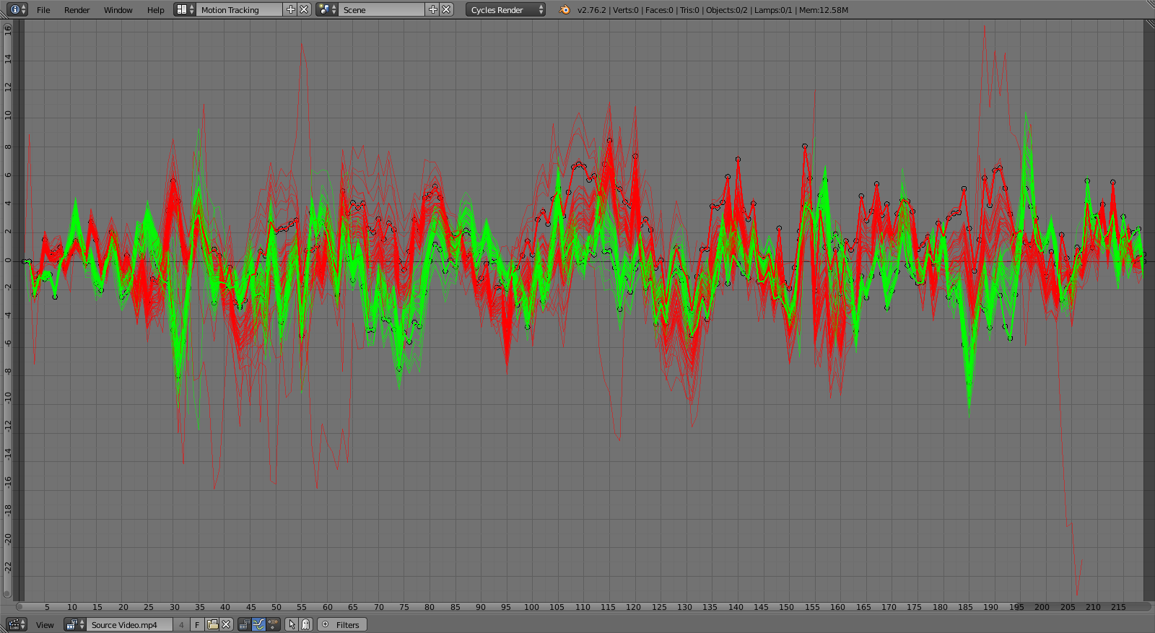
Graph View.

Introduction
The graph or curves view has numerous purposes based on the color of the lines. The red and green lines on the graph show you the speed of the trackers at a given frame. Green is vertical movement, Red is horizontal. Therefore the first frames will always be at zero.
The blue line is the line that comes out when you click on the film strip is the average per frame error. This curve is available only after pressing camera solve and is not editable. This is the one line that you want to be as flat as possible and as closer to zero as you can. The high points will show you where in your shot you are having inaccurate tracking.
Frames outside of scene frame range are darkened.

Header
Show
Only selected (mouse cursor icon) Hidden (ghost icon)
Filter
Display options.
Frames
ToDo.
Motion
ToDo.
Error
Per-frame reprojection error of tracks.

Usage
The curves are useful to see if particular trackers are moving differently than the average. A line that spikes from the rest of the curve usually means a tracking error.
You can manually edit the curve by selecting a point in the curve and dragging it or deleting, that will affect the corresponding tracker on that particular frame.
Lock to Time Cursor
Locked the time cursor the view center.

Dope Sheet View

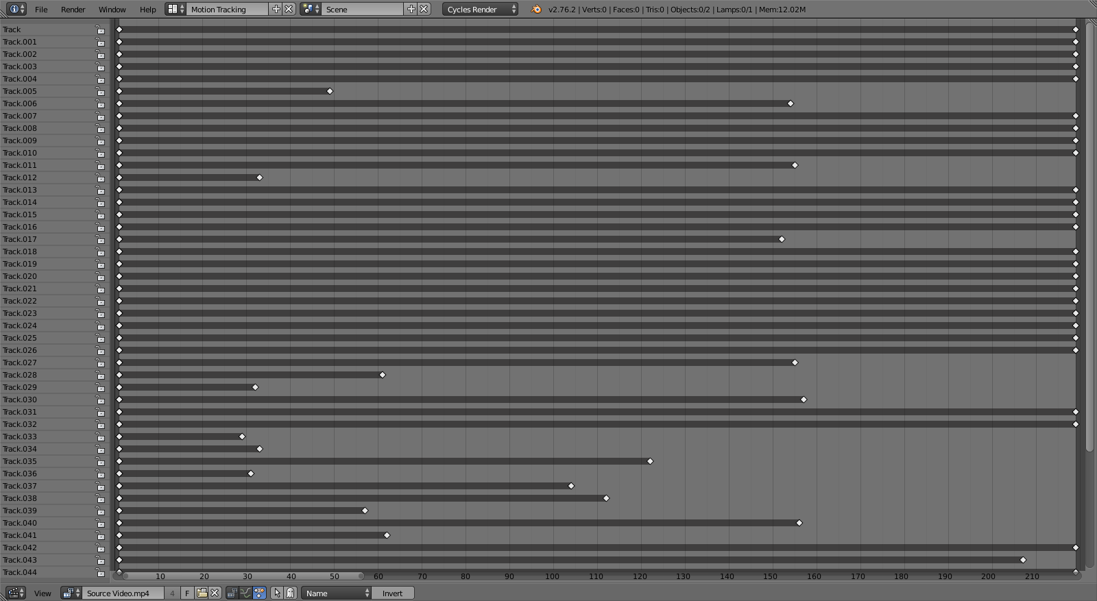
Dope Sheet View.
The dope sheet view is used to visualize motion tracking data, it implemented as separate view of the movie clip editor just like the Graph View.
It displays channels for selected tracks and each channel visualizes tracked segments of tracks as dark bars and keyframed positions of tracks as small diamonds.
The background is highlighted depending on the number of tracks in a frame. This means that if for a frame (or sequence of frames) there are less than eight tracks, the background will turn red;if there are from eight to sixteen tracks, the background will be yellow.
This is only a visual feedback, which doesn’t mean that the camera motion will not reconstruct with less than eight tracks. It only means that you should pay attention to those frames and check if all possible good feature points are tracked there. Remember, if there are no good feature points in the frame and there are less than 16 tracks in the frame, it doesn’t mean the solution won’t be accurate. Rather, adding more tracks on bad feature points will reduce the accuracy of solution.

Header
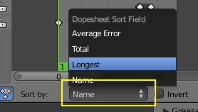
Sort Channels Order.
Show
Only selected (mouse cursor icon)
ToDo.
Hidden (ghost icon)
ToDo.
Sort Method
Sort order of the tracks.
Name
Sort selected tracks in alphabetical order based on their names.
Longest
Sort tracks by longest tracked segment length.
Total
Sort tracks by overall amount of frames.
Average Error
Sort tracks by their average reprojection error after solving camera or object motion.
Invert
To change the sort order from ascending to descending.

Usage
Currently the dope sheet view is for visualization and does not have any tools to actually edit data.

Masking Introduction

Masks have many purposes. They can be used in a motion tracking workflow to mask out, or influence a particular object in the footage. They can be used for manual rotoscoping to pull a particular object out of the footage, or as a rough matte for green screen keying. Masks are independent from a particular image of movie clip, and so they can just as well be used for creating motion graphics or other effects in the compositor. These masks can also be used in other places in Blender.

S-Curves

The curve type used for creating mask splines is almost a Bézier curve, but with some differences. Smooth edges of the mask are defined by feathering. The curve needed to support feathering in a way that stuck to the curve as you edited it, for ease of editing an animation. These are called S-Curves.
Besides the handles, every control point also has points that define the feather between the current point and the next point on the spline. Each feather point is stored in UV space, where U means position across spline segment, and V means distance between main spline and feather points.
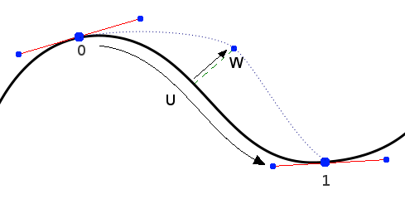
S- Curve Explained.
This allows for deforming the main spline in almost any way, and the feather will be updated automatically to reflect that change.
For example if there is just rotation of the spline, feather would stay completely unchanged. If one point’s feather is moved, the other feathers will be automatically stretched uniformly along that segment and the overall shape will be almost the same as artists would want it to be.

Primitives
Reference
Panel: Tool Shelf ‣ Mask ‣ Add

There are two primitives available: a Bezier Circle and a Square with vector handles.

Selection & Editing

Selection

Editing
The tools and panels available to edit masks are the same in both editors. Editing of mask splines happens in a way similar to editing Bézier curves or paths in GIMP or other curve editors.
Tip
To get interactive feedback on the resulting mask, a Mask node can be connected directly to a Viewer node in the compositor, which will then keep updating the compositing result while editing.

Control Points
Add Vertex and Slide
Ctrl-LMB is used to place new control points and define handle orientations by a continued mouse drag. A Ctrl-LMB double click will also close the curve if the last point was selected.
Transform
Existing control points can be slided with LMB and translated, scaled and rotated with the usual G, S, R shortcuts. The whole spline can be move by dragging the center dot with LMB.
Toggle Cyclic
Toggle to create a close curve or open it again. Close the mask by joining the last control point to the first.
Delete
Removes control points.

Curve Handles
Slide Spline Curvature
LMB click on curve and drag to move the handle.
Set Handle Type
Set handle type for selected spline points.
Recalculate Normal
Make normals (handle directions) consistent.
Switch Direction
Switch Direction handle directions in/out.

Feather
Add Feather Vertex and Slide
Shift-LMB is used to define a feathering outline curve. To create an initial feather, sliding from a spline control point outside or inside will create and position feather points. After this Shift-LMB will insert new feather point and mouse sliding can be used to move them around.
Scale Feather
Will scale the feather size.

Animation
Masks can be animated with the shape keying system. This can be useful when there are not enough good feature points to track in the footage, or the mask is not based on footage. Mask animation timing can be edited from the Dope Sheet Mask mode.
Insert Shape Key
Will insert a shape key for the active mask layer at the current frame. This works on the level of mask layers, so inserting a shape key will keyframe all the splines and points contained in it.
Clear Shape Key
Will clear the shape key for the active mask layer at the current frame.
Feather Reset Animation
Resets the feather offset across all animated frames.
Re-Key Points of Selected Shapes
Re-interpolate selected points on across the range of keys selected in the dope sheet.

Show/Hide

Properties

Mask Layer
Mask Layer
Mask layers consists of one or several splines and used to “grouped” operation on splines. Layers can be used to create complex shapes and to define how the splines interact with each other. Splines belonging to the same layer can be animated together, for example by an item from motion tracker footage. Example of such tools might be parenting the whole set of splines to single motion tracking data or simple to transform all of them together.
Opacity
ToDo.
Invert
ToDo.
Blend
ToDo.
Falloff
Feather. ToDo.
Overlap
Detect self intersections. ToDo.
Holes
Option not to treat overlapping curves as holes. Concentric splines will generating holes in the mask.
By creating overlapping splines holes can be created, and it’s the layer membership that defines which splines interact to create holes. As addition, splines from the same layer are behaving in a way, that concentric splines are defining holes in mask, but if two splines from different layers are concentric they wouldn’t define hole – they’ll just be union in final mask.

Example
The purpose of mask layers can be explained with an example. Suppose there are two unwanted people in the footage, and one of them goes from left to right, and the other in the opposite direction. Two mask layers can then be used to mask them separately using a single mask data-block. At the point of intersection of these shapes they will be added together rather than creating a hole, as would happen if they were on the same layer. If the motion is simple enough, a single motion tracked point can be used to drive the location of the entire mask layer.

Mask Display
Smooth
Display the edge anti-aliased.
Edge Draw Type
Style of the edge.
Overlay
Added mask overlay to both image and clip editors.
Mode
Alpha Channel
Which displays rasterized mask as a grayscale image.
Combined
Which multiples image/clip with the mask.

Active Spline
Feather Offset
ToDo.
Weight Interpolation
ToDo.
Cyclic
If the spline is closed or not.
Fill
Disable calculation of holes.
Self Intersection Check
Fill self intersections.

Active Point
This panel is shown when both a tracking marker and mask is selected.

Parent
In the Movie Clip Editor it is possible to link the whole mask or its points to motion tracks. This way the mask or points will follow the tracks.
Make Parent
Parents one or more selected spline points to the active motion tracker.
Clear Parent
Clears any parenting relationship for the selected spline points.
Parent
Data ID to which the mask or spline is parented to in case of parenting to movie tracking data set to Movie Clip data-block.
Type
Point Track, Plane Track
Object
Object to parent to.
Track
Name of individual tracks.

Mask Settings
ToDo.

Proxy/Timecode Panel

Once you have chosen the Proxy/Timecode parameters, you need to use Clip ‣ Proxy ‣ Rebuild Proxy and Timecode indices to generate the proxy clip and it will be available after Blender makes it.

Proxy
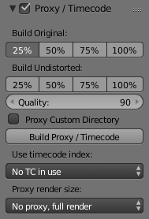
A proxy is a smaller image (faster to load) that stands in for the main image. When you rebuild proxies Blender computes small images (like thumbnails) for the big images and may take some time. After computing them, though, editing functions like scrubbing and scrolling is much faster but gives a low-res result. Make sure to disable proxies before final rendering.
Build Original
Used to define which resolutions of proxy images should be built.
Build Undistorted
Builds images from undistorted original images for the sizes set above. This helps provide faster playback of undistorted footage.
Quality
Defines the quality of the JPEG images used for proxies.
Proxy Custom Directory
By default, all generated proxy images are storing to the <path of original footage>/BL_proxy/<clip name> folder, but this location can be set by hand using this option.
Rebuild Proxy
Regenerates proxy images for all sizes set above and regenerate all timecodes which can be used later.
Timecode
See Timecode.
Proxy Render Size
defines which proxy image resolution is used for display. If Render Undistorted is set, then images created from undistorted frames are used. If there is no generated proxies, render size is set to “No proxy, full render”, and render undistorted is enabled, undistortion will happen automatically on frame draw.

Timecode
When you are working with footage directly copied from a camera without pre-processing it, there might be bunch of artifacts, mostly due to seeking a given frame in sequence. This happens because such footage usually does not have correct frame rate values in their headers. So, for Blender to calculate the position of a needed frame in the stream works inaccurately and can give errant result. There are two possible ways to avoid this:
- Preprocess your video with, say, mencoder to repair file header and insert correct keyframes.
- Use Proxy/Timecode option in Blender.

Options
Timecode
Timecode to use on the selected movie strip.
The following timecodes are supported:
- No TC in use- do not use any timecode
- Record Run
- Free Run
- Free Run (rec date)
- Record Run No Gaps

Note
Record Run is the timecode which usually is best to use, but if the clip’s file is totally damaged, Record Run No Gaps will be the only chance of getting acceptable result.

Display Panel

This panel contains display settings related on editor itself.
Channels
The R, G, B toggles control the color channels used for frame preview. It is needed because the tracking algorithm works with gray-scale images and it is not always obvious to see which channels disabled will increase contrast of feature points and reduce noise.
Grayscale Preview (B/W)
Shows the whole frame grayscale.
Mute (eye icon)
Changes displaying on movie frame itself with black square, It helps to find tracks which are tracked inaccurately or which were not tracked at all.
Render Undistorted
ToDo.
Lock to Selection
Makes the editor display selected tracks at the same screen position along the whole footage during playback or tracking. This option helps to control the tracking process and stop it when the track is starting to slide off or when it jumped.
Display Stabilization
This option makes the displayed frame be affected by the 2D stabilization settings (available in reconstruction mode only). It is only a preview option, which does not actually change the footage itself.
Grid
Displays a grid which is originally orthographic, but is affected by the distortion model (available in distortion mode only). This grid can be used for manual calibration – distorted lines of grids are equal to straight lines in the footage.
Calibration
Applies the distortion model for grease pencil strokes (available in distortion mode only). This option also helps to perform manual calibration. A more detailed description of this process will be added later.
Display Aspect Ratio
Changes the aspect ratio for displaying only. It does not affect the tracking or solving process.

